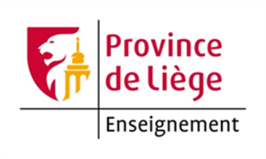
How about a semester in English in International Business ? In the French speaking part of Belgium
YOU WANT :
- To develop a solid knowledge in international trade ;
- To become an expert in international marketing ;
- To understand and master the different aspects of geopolitics ;
- To acquire the basics in international insurance ;
- To approach exports in a context of international and global strategy ;
- To develop your creativity ;
- To acquire an inter-cultural training and experience ;
- To experience negotiating by practical exercises (seminar) ;
- Experiment with starting up a company working with a group of international students ;
- Meet students from all over the world ;
WE OFFER YOU :
- One semester (from September to mid-January) in English in the second year of a bachelor degree in foreign trade ;
- A team of professors versed in the « dynamic » teaching methods ;
- Courses tied in with the real world ;
- Seminars to put into practice the theories learnt ;
- One week of complete integration ;
 | NAME OF UNIT | COURSES | HOURS | ECTS
Unit 1 | MANDATORY COURSES  International Marketing | Entrepreneurship  International Marketing | 30  75 | 9
Unit 2 | MANDATORY COURSES  Geopolitics and Intercultural Management | Geopolitics  Cross Cultural Marketing | 45  15 | 5
Unit 3 | Overseas Export | Oversea Exports  International Insurance | 30  30 | 5
Unit 4 | Creativity | Creativity  Seminars | 15  60 | 3
Unit 5 |  | English | 60 | 4
Unit 6 |  | German or Spanish | 45 | 4
Unit 7 |  | French for foreign | 60 | 5
Unit 8 |  | Introduction to Chinese culture and language | 30 | 2
Unit 9 |  | Introduction to Russian culture and language | 30 | 2

Unit 1 : Entrepreneurship, International Marketing
Entrepreneurship : Students have to:
- come up with an innovative idea/product/service ;
- test the practicality of their project from a marketing and financial point of view ;
- write a complete business plan ;
- present their projet.
International Marketing :
This course will teach students how to integrate marketing concepts into the international context and specially product and pricing strategies. It explains the structure, the functions of the export company and its development on a world wide scale.
Unit 2 : Law module 2/oversea exports
Overseas Export :
The course is aiming to deliver theoritical and practical methods to start and exploit an export oriented business operating in an international environment. Understanding of existing standards as a tool to collect, organise and use outside information about export. The lecture delivers basic methods to define and use generic and specific tools in export business as well as in the uses of commercial practices in multi-cultural trading.
International Insurance :
This course is to understand and use appropriately trade-credit insurance technique, to understand the role of credit insurance, the role of insurance.
Unit 3 : Creativity, Seminars
Creativity :
This course is to help a team, thanks to several techniques, approach a problem or a challenge in an imaginative and innovative way (to think out of the box) and come up with breakthrough ideas.
Seminars :
This course is to stimulate the understanding and on-site knowledge of several aspects of international trade, to act as a kind of eye-opener, that helps you see the corporate world as it actually is, makes you come to a realization of the tasks and skills required or that can even change your perspective and to get the students to be involved in a “hands-on experience” and to use the proper soft skills.
Unit 4 : English
This course is to practice the language structures at a more advanced level, is to extend the students’ vocabulary in lexical areas ranging from everyday situations to foreign trade-oriented topics.

Unit 5 : German or Spanish
Theses courses teach knowledge of the language skills developed in the first course unit, grammatical structures as well as basic vocabulary.
Unit 6 : Geopolitics, Cross Cultural Marketing
Geopolitics :
The course introduces to the logics of geopolitics and geo-economics in a comparative perspective. After a brief introduction to the main concepts of this approach and some applications to industrialized democratic countries, to former Communist bloc countries and to developing countries.
Cross Cultural Marketing :
Students will learn that communication depends on its context (high and low, implicit and explicit, personalization, depersonalization, time, religions…). They will also learn how to communicate within a culture and how to adapt one’s behaviour in different cultures (mental programming, cultural & noncultural factors, sources, customs, and stereotypes). International negotiation will close this course.

Higher Education Institution of the Province de Liège
Head Office: Quai des Carmes, 45
4101 Jemeppe – Belgium
Website: http://www.hepl.be
Central International Relations Office
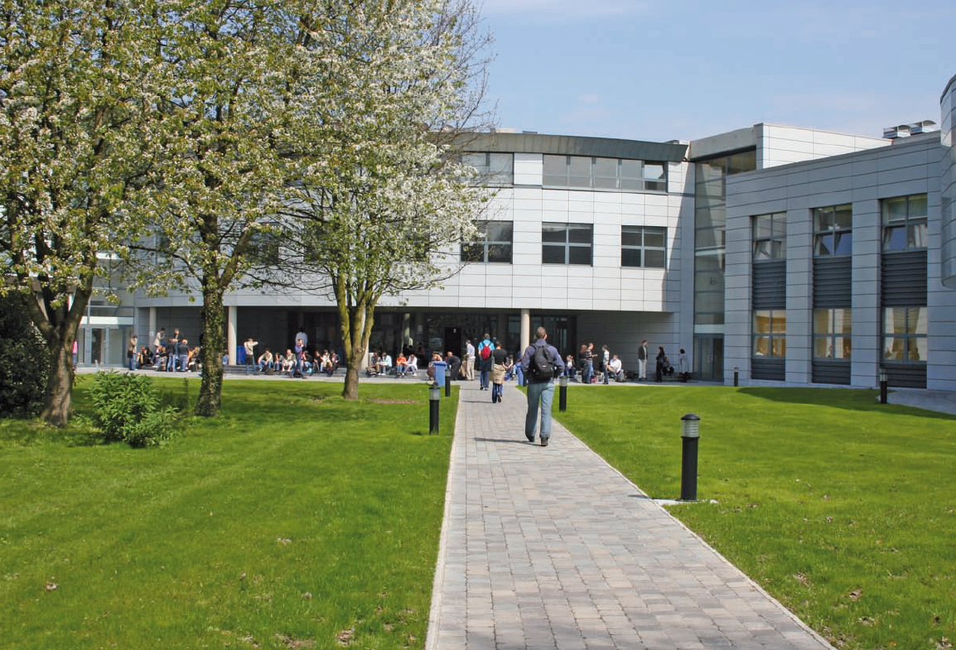

Departmental Coordinator : Morgane LAMOUREUX
Morgane.lamoureux@hepl.be

Head Officer : Philippe PARMENTIER
International Office Manager
Tel: +32 (0) 4 237 96 19
Fax: +32 (0) 4 237 26 88
E-mail: Philippe.parmentier@hepl.be

Administrative staff : Pauline BACQUELAINE
Pauline.bacquelaine@provincedeliege.be

